# Unit 11: Do we find humanness in freedom?

## Overview

An archetype (universal symbol) of freedom is a bird in flight. By contrast, a caged bird symbolizes loss of freedom. We seem to connect emotionally to the upward, seemingly limitless movement of flight, the sensation of wind and air, and the feeling of being above the earth. Is this quest for freedom part of our humanness? Do we become more human when we have freedom and less human when we are “caged” in some way? Or does the experience of losing freedom actually draw us closer to understanding our humanness? These are the questions to bring with you into Unit 11.

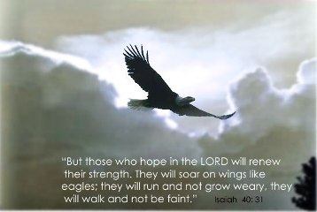

Figure 11.1. **[Check original source for CC license.]** Image source: Thisischurch.com

## Prompts

Unit 11 will look at two kinds of prompts:

1: Malala Yousafzai’s Nobel Prize Speech

2: Instagram: Everyday Incarceration

## Learning Outcomes

Through practicing inquiry in this unit, you will:

* Question the relationships between freedom (and lack of), humanness, and the good life
* Inquire about different kinds of freedom
* Analyze and interpret portions of Malala’s speech
* Examine the meaning of freedom in a global context
* Practice meaning-making from a collection of images on Instagram
* Compare and contrast your own experiences and perspectives of freedom
* Reflect on the nature and character of God in relation to questions of humanness

## Activity Checklist

Here is a checklist of learning activities you will benefit from in completing this unit. You may find it useful for planning your work.

|  |  |
| --- | --- |
| 🗹 | **Activities** |
|  | Activity 11.1: Listen to *The Doors*, “[Universal Mind](https://www.youtube.com/watch?v=T0nE7FU_pF4).” You can look up the lyrics if you like. |
|  | Activity 11.2: Journal for approximately 5 minutes in response to the quote by Jim Morrison (of *The Doors*). Do you agree? How does he seem to define freedom? |
|  | Activity 11.3: Read the background on Malala |
|  | Activity 11.4: In your journal, discuss the related questions. |
|  | Activity 11.5: Read background of the Nobel speech and then watch the video of her speech. |
|  | Activity 11.6: Respond in your journal to the related questions. |
|  | Activity 11.7: Read the brief background on the Instagram project, [Everyday Incarceration](https://www.instagram.com/everydayincarceration/). |
|  | Activity 11.8: Browse through the images and read the accompanying descriptions. |
|  | Activity 11.8: Meet with your group to discuss what you learned from the photo collection. Complete the Group Discussion Template as a record of your discussion and post it. |

**Assessment**

Here is the assessment for Unit 11.

|  |  |
| --- | --- |
| **Group discussion**: Do we find humanness in freedom? | 2% |
| **Inquiry Blog #5** | 2% |

*Note that your final two assessments, the* ***Critical Summary*** *and the* ***Final Project****, will be discussed in next week’s wrap up unit.*

## Prompt 1: Malala Yousafzai’s Nobel Prize Speech

Malala Yousafzai has become a renowned figure, a young woman who advocates for the rights of girls to be educated and to have a voice. In 2014, she received the Nobel Peace Prize for her courage and her founding of the Malala Fund. In her speech, she describes some of her life experiences but mainly focuses on the importance of education for all children. We will listen to a portion of her speech and consider what her words and testimony reveal about free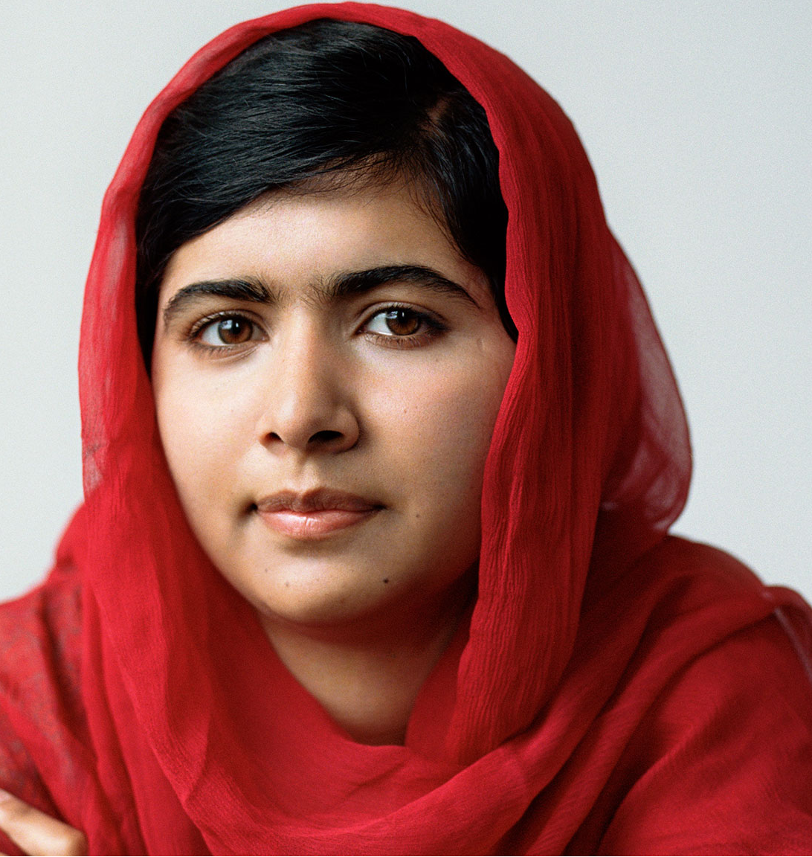

Figure 11.2. **[Check original source for CC license.]** Image source: sachtimes.com

### Learning Activities

#### Activity 11.1: Universal Mind

Listen to *The Doors*, “[Universal Mind](https://www.youtube.com/watch?v=T0nE7FU_pF4).” You can look up the lyrics if you like. The video is interesting and somewhat bizarre, but if you prefer to just listen without the visual, that’s fine as well.

#### Activity 11.2: Journal Response

Journal for approximately 5 minutes in response to the quote below by Jim Morrison (of *The Doors*). Do you agree? How does he seem to define freedom?

|  |
| --- |
| “The most important kind of freedom is to be what you really are. You trade in your reality for a role. You trade in your sense for an act. You give up your ability to feel, and in exchange, put on a mask. There can't be any large-scale revolution until there's a personal revolution, on an individual level.  It's got to happen inside first.”  ― **Jim Morrison** |

#### Activity 11.3: Malala Background

Read the background on Malala and with your group, discuss the related questions.

**Who is Malala?**

* Born in 1997 in Pakistan, in the Swat Valley

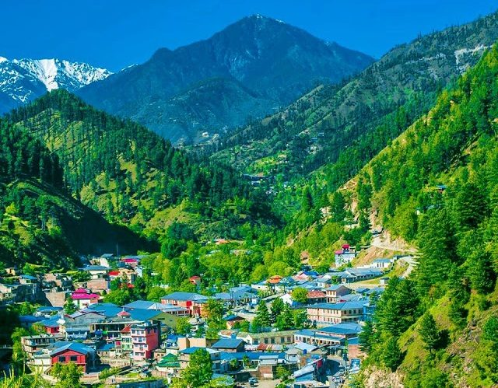

Swat Valley BEFORE: (Image source: Image: Paki Holic)

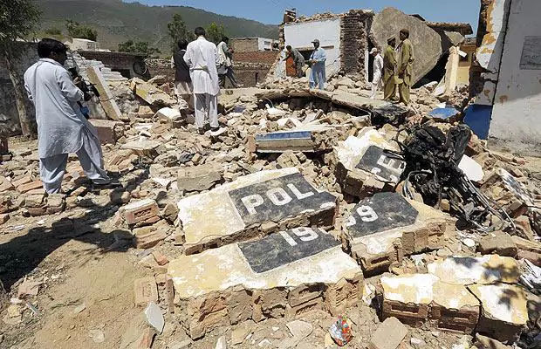Swat Valley AFTER: (Image source: The Telegraph) **[check copyright for photos]**

* Father is an educator and an activist who believes in equality and committed to raise his daughter no differently than a son
* In 2009, Malala began to speak and blog about education advocacy
* At great risk to her safety, Malala advocated for girls to attend school
* After her identity became public, on October 9, 2012, the Taliban targeted Malala on her school bus. They shot her in the head, neck, and shoulder. Two of her friends were injured.
* The injury left her clinging to life, required reconstruction of her skull.
* Malala survived and now uses her platform to speak to the highest levels of leadership, such as the United Nations
* One year after her attack, Malala and her father set up the Malala Fund to support the education of girls, and Malala joins with girls around the world

**Malala’s Context:**

* Female education in Pakistan became illegal in January 2009.
* Taliban – a group of extremists that may have arisen within the Afghan youth who were in refugee camps in Pakistan, later in Saudi-funded madrassas (seminaries), “motivated by the zeal of religion and the belief that they were ordained to bring stability and the ways of Allah back” (Amin, DeGeorges & Osinski, 2010, p.33).
* Impact of the Taliban (who took control of Swat in 2007) – destroyed many schools for girls, banned girls from shopping, made television and music illegal, destroyed cultural and religious artifacts (Who are the Taliban, 2016).
* Punishment for disobedience was execution or amputation

#### Activity 11.4: Journal Response

Malala said, “When I survived the attack and when I woke up in the hospital, my mind was very, very clear, that this life is for a cause… This is a second life, and it is given to me for something greater than what I was before” (Gidda, 2017).

In your learning journal, respond to the following questions:

* What do you learn about humanness through Malala’s discovery?
* Can girls in Pakistan live a “good life?”
* What kinds of freedoms have they lost? What kinds of freedoms do they still have?
* Do you take these freedoms for granted?

#### Activity 11.5: Nobel Speech

Read the background of the Nobel Speech and then [watch the video](https://www.youtube.com/watch?v=MOqIotJrFVM) of her speech. It is long, so you may want to watch only up to 11:25. Watch the entire speech if you like.

**Background of the Nobel Speech**

* December, 2014, Malala was awarded the Nobel Peace Prize (along with fellow activist, Kailash Satyarthi)
* Malala is the youngest person to be given this award and the first Pakistani woman
* Malala speaks not as one girl but as all the girls who have shared their stories with her

#### Activity 11.6: Journal Response

Study each quote from the speech and respond in your journal to the related questions. Feel free to share additional thoughts and questions with your group as you meet this week.

1. Malala offers thanks:

“Thank you to my father for not clipping my wings, and for letting me fly.”

“An Indian and a Pakistani can work together and achieve their goals of children’s rights.”

* What do these comments tell you about Malala’s view of freedom?

1. Malala advocates for children who are deprived of education and for the rights of women to be educated.

* How is the role of advocacy related to freedom?

1. Malala says, “Now is not the time for pity.”

* What are the results of pity?

1. Malala says that when her world changed, her priorities changed. She realized she had two choices: to be silent and be killed, or to speak and be killed.

* What does this say to you about freedom?

1. The Taliban tried to take away the freedom and the voices of young women, but Malala says, “Since that day, our voices have grown louder and louder.”

* Discuss this in the context of freedom and humanness.

1. The following quote is not from the speech but rather from a critique in response to Malala’s fame.

“… back home in South Asia, many have criticized how Western media outlets and institutions have conferred a kind of celebrity status on Yousafzai. Her “importance lies in her ability to be ordinary and still live an ethical and inspirational life,” says Indian author Tabish Khair, who has written about Yousafzai. “To make her into an idol is to deny this, reduce it … Perhaps if Malala can go on and achieve something that is not seen as just an idolizing benediction by the West—which, unfortunately, the Nobel was widely perceived to be in the non-West—it would mean much more for such ordinary heroines” (Gidda, 2017).

*For more on the notion of Malala as a colonialization figure, see Oleson (2016)*

* By becoming an advocate and a celebrity, has Malala lost or gained freedom?

1. Looking back over Malala’s story, what does it show you about our question:

* “Do we find the meaning of our humanness through freedom?”
* “What is the good life?”

## Prompt 2: Everyday Incarceration

Instagram is used for more than displaying vacation photos or amateur photography. In this collection, we are called into an exploration of the lives of convicts and their families in US prisons over the past 40 years. Photos are current and archival, curated by Zara Katz & Lisa Riordan Seville. There are a lot of stories to look at, and although we won’t be able to follow all of them, we will glimpse new ways of understanding the impact of freedom and incarceration on these families. We will also consider how photography can be used to create and question meaning.

### Learning Activities

#### Activity 11.7: Background of Everyday Incarceration

Read below the brief background on the Instagram project, [Everyday Incarceration](https://www.instagram.com/everydayincarceration/).

**Background on *Everyday Incarcerations*:**

The co-curators and journalists of this project want to tell the story of prison from new perspectives or at least challenge us to consider the humanness of people who live in prison. They wondered how photography creates or breaks biases about people who live behind bars: “This is the third and final article in a series that investigates what images do in relationship to criminal justice reform. Do images inform? Do they distract? Do they complicate or dumb-down urgent issues?” These are fantastic questions to lead us into our inquiry. If you would like to look at the other two articles and the collections of photography, go to [Listening to those who are photographed](https://medium.com/vantage/listening-to-those-who-are-photographed-e65e2f80fa56) and [I ride a 9-hour overnight bus to see my husband in prison](https://medium.com/vantage/how-it-feels-to-ride-an-overnight-bus-to-see-a-loved-one-in-prison-d27bd1e9d9a1). About the collection we will look at, this is what the journalists say in [Vantage magazine](https://medium.com/vantage/prison-is-where-families-go-7ae22b47e800): “Prison Is Where Families Go. If you look close enough at photographs from prisons you’ll see parents, grandparents, partners and kids as much as you will bars, cellblocks and razorwire.”

What will these images show you about our question, “Do we find humanness in freedom?”

#### Activity 11.7: Everyday Incarceration

Browse through the images on [Everyday Incarceration](https://www.instagram.com/everydayincarceration/) and read the accompanying descriptions. There are a lot of options, and you won’t be able to look at everything. You may want to follow a couple of the stories of individuals and their families, or you may prefer to sample a few photos that stand out to you.

## Assessment

### Group Discussion: Do we find humanness in freedom?

After completing this unit, including the learning activities, meet with your group to discuss what you learned from the *Everyday Incarceration* photo collection. Complete the Group Discussion Template as a record of your discussion and post it.

### Inquiry Blog #5:

For your last inquiry blog assignment, offer a new prompt that leads us to reflect on the meaning of sacrifice, salvation, and/or freedom. You can suggest any kind of prompt, such as a reading, a video, a movie or movie scene, music, poetry, art, sports, experience, interview, speech, etc. Explain how you think this prompt contributes to the questions we have been exploring in this course.

OR

Suggest a new topic or question related to exploring the good life. Write an explanation of your thoughts on this topic and why you think it is important to consider.

## Unit 11 Summary

In the song simply called [“Freedom,”](https://genius.com/Lecrae-freedom-lyrics) contemporary rap artist, Lecrae, writes,

“Freedom isn't free

But I still, I still believe in my freedom

So my mind can see

Please let me be free, please let me

Freedom”

The story of Malala and the experiences of men and women incarcerated in US prisons remind us that we cannot take freedom for granted. It “isn’t free;” it comes at a cost. However, perhaps our humanness drives us to believe in the possibility of freedom, if not physical freedom then mental and spiritual freedom, freedom from our old ways, freedom from the trappings of our past and our society’s destructive patterns. Can we have “the good life” without it?

## References

Amin, A.H., DeGeorges, P.A. & Osinski, D.J. (2010). *The Development of Taliban Factions in Afghanistan and Pakistan : A Geographical Account, February 2010*. Lewiston [N.Y.] : Edwin Mellen Press. Retrieved from Library OneSearch.

Everydayincarceration. (n.d.). Everyday Incarceration [Instagram Post]. Retrieved from <https://www.instagram.com/everydayincarceration/>

Gidda, M. (2017). Malala's new mission. *Newsweek Global*, *167*(26), 34-39. Retrieved from Library OneSearch.

Lecrae. (2016). Freedom. On *Church Clothes 3*. Atlanta: Reach Records.

Malala Fund. (2017). [www.malala.org](http://www.malala.org/)

Olesen, T. (2016). Malala and the politics of global iconicity. *British Journal Of Sociology*, *67*(2), 307-327. doi:10.1111/1468-4446.12195

Schnee, A. (2016). Malala Yousafzai. *Salem Press Biographical Encyclopedia*. Retrieved from Library OneSearch.

Seville, L.R. (2016, March 9). Prison is where families go. *Vantage*. Retrieved from <https://medium.com/vantage/prison-is-where-families-go-7ae22b47e800>

Who are the Taliban? (2016, May 26). BBC Asia. Retrieved from <http://www.bbc.com/news/world-south-asia-11451718>

Yousafzai, M. (2014, December 11). Nobel Peace Prize Speech. *Malala Fund*. Retrieved from <https://www.youtube.com/watch?v=MOqIotJrFVM>